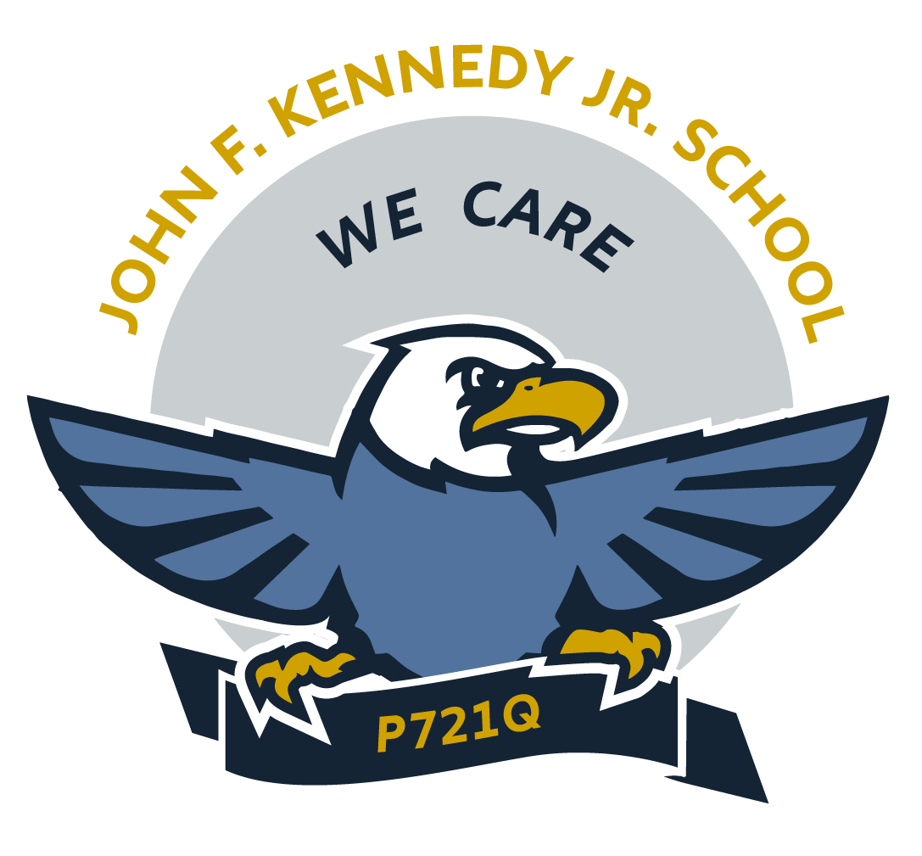
Unit Planning Template

Teacher: | Class: | Date:
Unit Title: | Unit Length:

Unit Overview/ Knowledge:

Unit Brainstorm: ( Can use clouds, boxes, charts, etc.)

Essential Questions:

Standards/ Essential Elements

Focus Standards:  Standards for the unit | Ongoing Standards:  Standards that will be continuously addressed

Skills:

Scaffolded Learning Targets (Stems to begin with: I can... I Know...
I’m learning how to... When I learn this... We are learning that...

Knowledge
(Identify, Describe, List)
Reasoning
(Infer, Compare, Evaluate)
Skills
(Use, Operate, Explore)
Product
(Draw,Write, Create, Design, Model)

Unit Assessments

Formative  Assessments that inform instruction and progress towards learning goals (Checklist, Exit Slip, Rubric) | Summative  Assessments that allow students to demonstrate or apply what they have learned throughout the unit (Portfolio, Essay, Presentation, Skit)

Vocabulary:
Vocabulary related to theme, learning goals, and/or concepts throughout the unit.

Chore

Materials & Resources:
(Texts, websites, technology, personnel,etc.)

Performance Task:

Monday | Tuesday | Wednesday | Thursday | Friday | Week Ending
KWL chart to assess prior knowledge

(Indoor chores/
washing dishes)

KWL chart to assess prior knowledge
(preparing a
meal)

